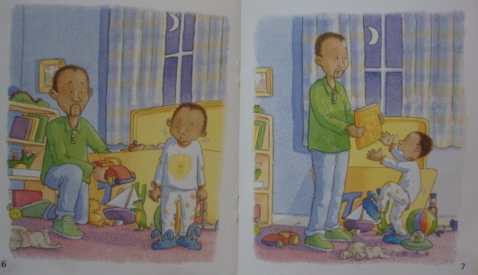
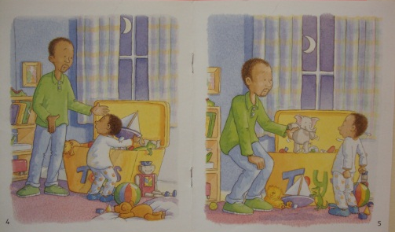
Wordless
Reading Books

What are the benefits of wordless picture books?
1) They develop a child's oral language. Wordless picture books allow children to create stories using experiences, prior knowledge, and their understanding of the events in each illustration.
2) Since there are no words on the page to define, limit, or prescribe a story; each child can create his or her own story. This allows the child to include his or her own culture, values, and understanding within the story.
3) Connections made by the student to the story will allow for comprehension and oral language development as they communicate both the story and the meaning to others.
4) It helps children develop knowledge of story structure. Children who tell stories using wordless picture books demonstrate an understanding that stories must have a beginning, middle, and an end.
5) It also shows a student's ability to correctly handle a book, read left to right, demonstrate their understanding of what should be included in a good story, and in what order the story should be told.
6) When reading wordless picture books, children are able to describe and develop characters for their story. Younger children may only give a character's name, while children with more literacy experience may choose to include descriptive details of different characters.
7) Wordless picture books create text. Children can bring their own experiences and culture to the story they tell. When children read and listen to wordless picture books, they are exposed to the different cultures represented in their classroom.
8) Children have the opportunity to learn new vocabulary.

Some interesting links:

http://www.earlychildhoodnews.com/earlychildhood/article_view.aspx?ArticleID=690
http://www.childrens-books-and-reading.com/wordless-picture-books.html

