KG2NW
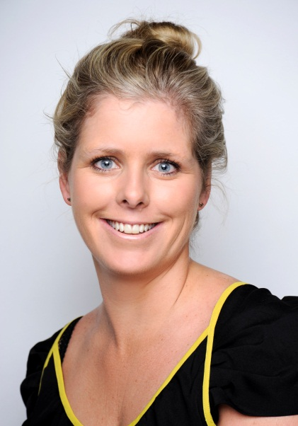
Ms. Nicola Wilcox, KG2 Teacher
Welcome to KG2NW! I am excited to be returning to GWA in August 2016 for my fifth year. This will be my third year teaching KG2 at GWA, for my first two years I taught Grade 2.
Dubai is very different to my home country of New Zealand, especially growing up in the country side on a farm! I attended Canterbury University in New Zealand where I obtained a Science Degree, double majoring in Geology and Geography. I followed this by completing a Post Graduate Diploma in Teaching and Learning (Primary) at Christchurch College of Education (NZ).
I have had over ten years teaching experience in New Zealand and Dubai. The majority of my time has been spent teaching the equivalent of KG2-Grade2 but have had time in a wide range of Grade levels through to Grade 7.
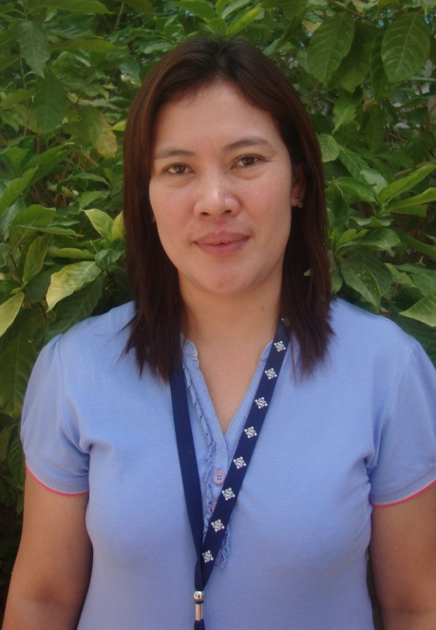
Outside of school I enjoy travelling and have visited and lived in a range of places around the world including countries from; Europe, Asia, America, Africa and the Pacific. My adventure continues as I explore Dubai and nearby places and all that they have to offer. I also enjoy sports and participate in netball, tennis, running, snow-boarding and general exercise.
I look forward to our year together as a team. If you have any questions please come and ask, my door is always open. If you wish to email, my school address is n.wilcox_gwa@gemsedu.com.

Mrs. Edna Pangilinan, KG2 Teaching Assistant
Our classroom assistant is Edna Pangilinan. She is from the Philippines and is a qualified elementary teacher. She taught for 11 years in the Philippines and, before coming to Dubai, she taught for two years in a Filipino school in Sharjah. This will be Edna’s seventh year at GWA, we are very lucky to have her in KG2NW!

