Welcome to KG2-EC

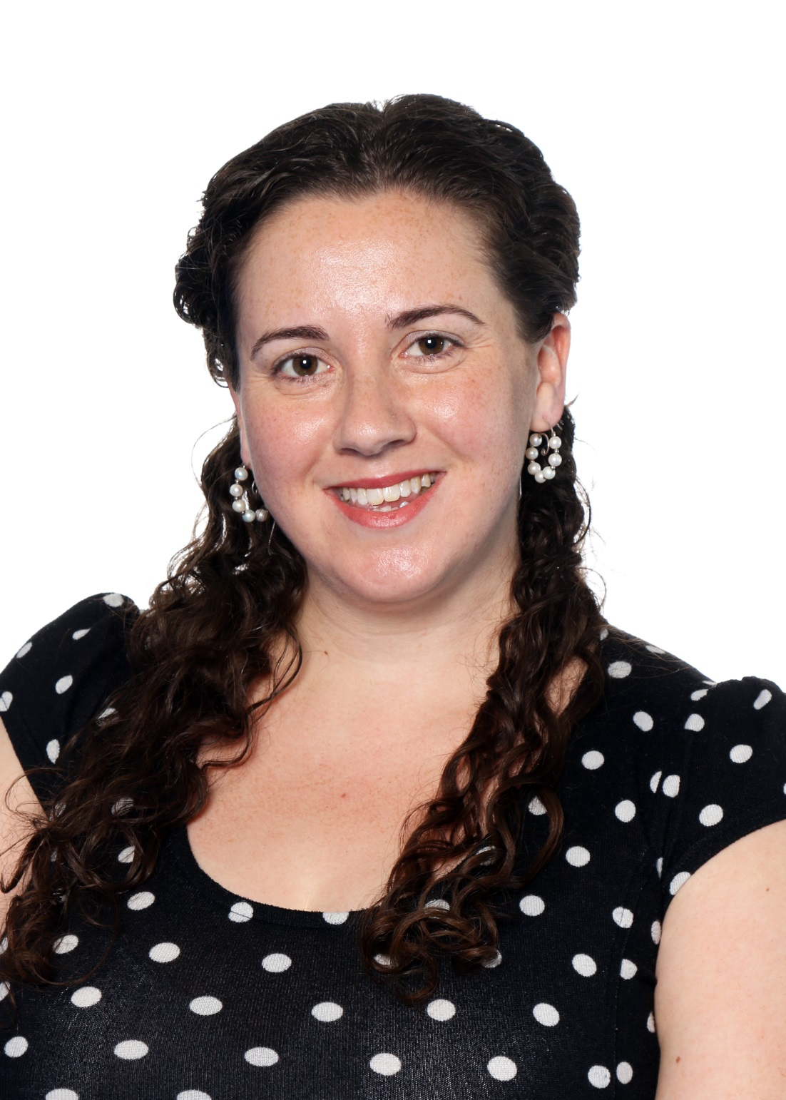
My name is Erin Coffin and I am excited to welcome you to KG2
at GEMS World Academy Dubai!

I was born and raised in Prince Edward Island, Canada. I
graduated from the University of Prince Edward Island in 2008
with a Bachelor of Arts degree. Afterwards, I travelled and
taught at schools in Costa Rica and South Korea for a year and a
half. In 2010, I obtained my Graduate Diploma in Teaching
(Primary) from the University of Auckland in New Zealand. My
first international teaching post was in 2012 at Centro Educativo
Internacional Anzoátegui in Venezuela where I taught Grade 1. For
the following two years, I was at the American School of Marrakesh in
Morocco where I taught KG1 and KG2.

This will be my second year in Dubai and at GWA. In addition to teaching KG2, I will be coaching elementary swimming and stage managing the high school production. I am so excited to be your child’s teacher next year and look forward to working with you to benefit your child’s education.

