Welcome to KG2-CM at GEMS World Academy!
We are very excited to start this year with you and your child. We would like to provide you with a short biography of ourselves so that you can get to know us better and hopefully develop a partnership to benefit your child’s education.
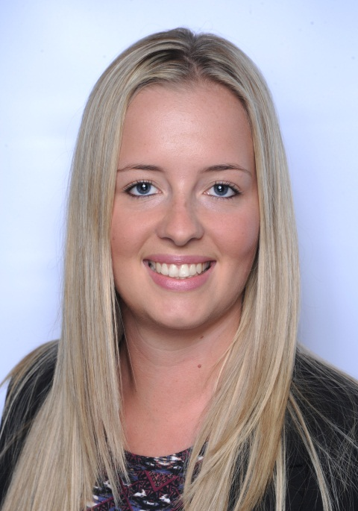
Teacher: Chantal McLaren
I was born in Pretoria, South Africa and moved to the United Kingdom when I was 9 years old. I lived and studied in Hertfordshire, England. I attended the University of Hertfordshire where I completed my Bachelors of Education degree in Primary Education. I speak both Afrikaans and English. In 2013 I got married to my husband Jack in Cape Town. Last year (August 2015), we welcomed our son Oliver.
I have been teaching for 7 years (4 years in the UK and 3 years in Dubai). I have previously taught Year 4 and Year 1 before coming to GWA.
I enjoy teaching Language and Maths and seeing children excel in these areas. I am an advocate of international-mindedness and hope to encourage students to become future global citizens.
I look forward to meeting you and your child!
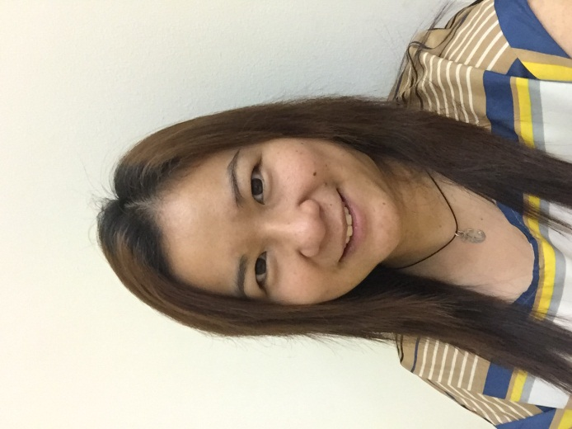
Teaching assistant: Charlene Lu Sia
Teaching has always been my passion. I am dedicated and committed to making learning fun as well as educational. In my home country, the Philippines, I was a KG2 teacher in a playschool. I’ve been a teaching assistant in one of the other international school in Dubai and this is my fifth year at GWA. I am looking forward to a great year!

