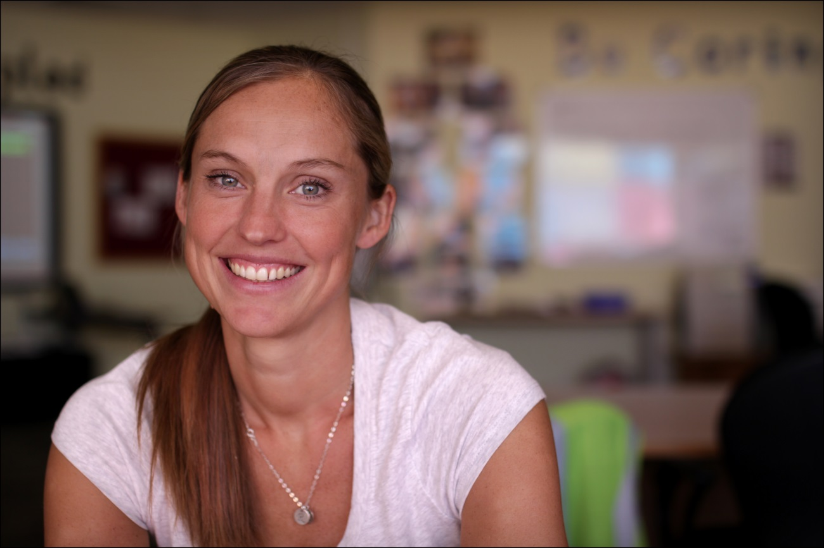
My name is Amy Bossler and I am very excited to be joining the KG2 team next year. I have been teaching at GWA for two years in Grade 3 and I am also one of the Elementary swim squad coaches. I am British, yet was born in Belgium, where I lived most of my life. I moved to Dubai in January 2014 with my husband, Mr. Bossler, he is teaching MYP PE in Secondary. We have two children, Rosella who is 3 ½ and will be starting Pre-K next year and Harvey who will be turning 2 soon. We all enjoy spending time at the pool whether it be playing, swimming or splashing. I am also a keen netball player and run to keep fit.
I qualified with a Bachelor of Education in 2004 from the University of Liverpool. I then taught kindergarten at a private school for girls in London, England. After deciding that I wanted to teach overseas I moved back to Belgium for two years to teach at The International School of Brussels. There I was able to take on more responsibilities within the Grade 2 team and I was head swim coach for the Secondary school team. I then moved to Malaysia with Mr. Bossler for four years. We lived on a small Island called Penang and taught at The International School of Penang (Uplands), where I taught the PYP from kindergarten through to grade 3. I have always had a passion for teaching and I’m especially fond of the Primary Years Program. I look forward to welcoming my students to their new classroom next year.

